Privacy and Public Policy Conference
February 9-10th, 2026
125 E St NW Washington, D.C.

Program Overview

Day 1 Monday, February 9th
8:00am - 8:45am Check-in & Coffee
8:45am - 9:00am Welcome and Opening Remarks
9:00am - 10:00am Opening Panel: “Data Privacy and the Public Interest: Where Policy Meets Practice”
10:00am - 10:15am Coffee & Tea Break
10:15am - 12:00pm Session 1: New Methods for Differentially Private Estimation and Learning
12:00pm - 1:30pm Lunch
1:30pm - 3:15pm Session 2: Rethinking Privacy: Concepts, Metrics, and Use Cases
3:15pm - 3:30pm Coffee & Tea Break
3:30pm - 5:00pm Lightning Talks and Poster Session
5:00pm - 5:15pm Poster Awards & Day 1 Wrap-Up
5:15pm - 7:00pm Networking Reception

Day 2 Tuesday, February 10th
8:00am - 9:00am Check-in & Coffee
9:00am - 10:00am Policy Panel: “Translating Privacy Technology into Privacy Law: How Privacy Researchers and Practitioners Can Support Policymakers”
10:00am - 10:15am Coffee & Tea Break
10:15am - 11:45am Session 3: Regulatory Realities of Privacy and Data Protection
11:45am - 1:00pm Lunch
1:00pm - 2:45pm Session 4: From PETs to Practice: Infrastructure and Applications
2:45pm - 3:00pm Conference Wrap-Up

Detailed Program

Day 1 Monday, February 9th
8:00am - 8:45am
Check-in & Coffee

8:45am - 9:00am
Welcome and Opening Remarks

9:00am - 10:00am
Opening Panel: “Data Privacy and the Public Interest: Where Policy Meets Practice”
Moderator: Sharon Gibbons, Co-founder, Augusta Griffin
Panelists (bios are found at the end of the program):
- Yaw Etse, VP of Data Engineering, Capital One
- Joe Calandrino, Assistant Professor, Carnegie Mellon University
- Naomi Lefkovitz, Senior Fellow, Future of Privacy Forum

10:00am - 10:15am
Coffee & Tea Break

10:15am - 12:00pm
Session 1: New Methods for Differentially Private Estimation and Learning
- S1.1: Differential Privacy Guarantees in Small Area Estimation
Soumojit Das* and Jörg Drechsler
- S1.2: Differential Privacy for Network Connectedness Indices
Tom A. Rutter, Yuxin Liu, and M. Amin Rahimian*
- S1.3: Privacy Amplification for Synthetic Data Using Range Restriction
Jingchen Hu, Matthew R. Williams*, Terrance D. Savitsky
- S1.4: Measuring Income Mobility Under Differential Privacy
Brett Mullins* and Miguel Fuentes
- S1.5: A Practical Guide to Differentially Private Deep Learning Using the Pseudo Posterior Mechanism
Alexander J. Preiss, Amanda Konet, Robert Chew*, Matthew R. Williams, Elan A. Segarra, David H. Oh, Erin Boon, Terrance D. Savitsky

12:00pm - 1:30pm
Lunch

1:30pm - 3:15pm
Session 2: Rethinking Privacy: Concepts, Metrics, and Use Cases
- S2.1: From Privacy Enhancing Technologies to Purpose-Limiting Technologies
Gabriel Kaptchuk*
- S2.2: Having Confidence in My Confidence Intervals: How Data Users Engage with Privacy-Protected Wikipedia Data
Harold Triedman*, Jayshree Sarathy, Priyanka Nanayakkara, Rachel Cummings, Gabriel Kaptchuk, Sean Kross, Elissa M. Redmiles
- S2.3: Towards A Taxonomy of Privacy for Digital Currencies in Regulated Environments
François-Xavier Wicht*, Christian Sillaber, Mirjam Eggen, Christian Cachin
- S2.4: Do You Really Need Public Data? Surrogate Public Data for Differential Privacy on Tabular Data
Shlomi Hod, Lucas Rosenblatt*, Julia Stoyanovich
- S2.5: What Does ε=1 Actually Mean in Practice? Building A Registry to Find Out
James Honaker, Gary Howarth, Andrew Gruen*

3:15pm - 3:30pm
Coffee & Tea Break

3:30pm - 5:00pm
Lightning Talks and Posters
- P.01: Privacy Preserving Data Access Primitives for Social Platform Data
Kyle Resnik, Christine Task*, Doyle Groves, Bennett Hillenbrand
- P.02: Optimal Resolution of a Data Sharing Trilemma: Statistical Power, Sample Complexity, And Privacy Budget
Yuxin Liu*, M. Amin Rahimian, and Marios Papachristou
- P.03: Layered, Overlapping, and Inconsistent: A Large-Scale Analysis of the Multiple Privacy Policies and Controls of U.S. Banks
Lu Xian*, Van Hong Tran, Lauren Lee, Meera Kumar, Yichen Zhang, and Florian Schaub
- P.04: Valid Inference Under Data Swapping
Kevin Eng*, Ruobin Gong, and Minge Xie
- P.05: Fully Synthetic Data for the American Community Survey
Michael Freiman*, Evan Totty, and Aref Dajani
- P.06: From Pilot to Implementation: Privacy Enhancing Technology in Action
Lisa B. Mirel*
- P.07: On The Rival Nature of Data Use in the Context of Privacy – Legal Applications
Ayelet Gordon-Tapiero, Muhammad Saad*, Katrina Ligett, and Kobbi Nissim
- P.08: Sites Of Indeterminacy: A Comparative Study of Differential Privacy Deployment in Public and Private Institutions
Jae June Lee* and Daniel Susser
- P.09: Differentially Private Linear Regression and Synthetic Data Generation with Statistical Guarantees
Shurong Lin*
- P.10: Data Governance Transformation: Now Is the Time to Revisit Data Governance Policy
Jacob M. Pasner*
- P.11: The Gift of Federal Statistics: Reframing the Givens in U.S. Public Sector Data Access
Jayshree Sarathy* and Danah Boyd
- P.12: Democratizing Innovation Microdata: How Synthetic Public Use Files Can Address the Credibility Crisis in Applied Economics
Audrey Kindlon, Jorge Cisneros, Timothy Wojan*, Matt Williams, Jennifer Ozawa, Robert Chew, Kimberly Janda, Timothy Navarro, Michael Floyd, DJ Streat, and Heather Madray
- P.13: Differentially Private Geodesic Regression
Aditya Kulkarni*, Carlos Soto

5:00pm - 5:15pm
Announce Poster Winners & Wrap Day 1

5:15pm - 7:00pm
Networking Reception
Sponsored by the ASA Privacy and Confidentiality Interest Group

Day 2 Tuesday, February 10th
8:00am - 9:00am
Check-in & Coffee

9:00am - 10:00am
Policy Panel: “Translating Privacy Technology into Privacy Law: How Privacy Researchers and Practitioners Can Support Policymakers”

Moderator: Tatiana Rice, Senior Director for U.S. Legislation, Future of Privacy Forum

Panelists (bios are found at the end of the program):
- Alan McQuinn, Professional Staff Member, U.S. House of Representatives
- Dylan Irlbeck, Legislative Assistant, Congresswoman Lori Trahan

10:00am - 10:15am
Coffee & Tea Break

10:15am - 11:45am
Session 3: Regulatory Realities of Privacy and Data Protection
- S3.1: What Regulators Actually Look for in Privacy Programs: Lessons From HIPAA, OCR, DOJ Bulk Data, And Global Enforcement Trends
Bridget M. Bratt* and Joseph A. Emerson
- S3.2: How to Think About End-To-End Encryption And AI: Training, Inference, Disclosure, And Consent
Mallory Knodel*, Andrés Fabrega, Daniella Ferrari, Jacob Leiken, Betty Li Hou, Derek Yen, Sam de Alfaro, Kyunghyun Cho, and Sunoo Park
- S3.3: Measuring User Responses to Online Age Verification
Yanzi Veronica Lin*, Cheng Zhang, Madelyne Xiao, Weiqian Zhang, Vivianna Lieu, Wenchao Hu, Lorrie Faith Cranor, and Sarah Scheffler
- S3.4: Privacy and Safety Experiences and Concerns of U.S. Women Using Generative AI For Seeking Sexual and Reproductive Health Information
Ina Kaleva*, Xiao Zhan, Ruba Abu-Salma, and Jose Such

11:45am - 1:00pm
Lunch

1:00pm - 2:45pm
Session 4: From PETs to Practice: Infrastructure and Applications
- S4.1: Full-Stack Output Privacy Risk Assessment
Shlomi Hod*, and Jayshree Sarathy*
- S4.2: Benchmarking Differential Privacy for Applied Public Policy Analysis
Aaron R. Williams*, Andrés F. Barrientos, Claire McKay Bowen, and Joshua Snoke
- S4.3: Natural Language Access to Privacy-Preserving Data: Integrating the Model Context Protocol with Differentially Private Query Engines
Bennett Hillenbrand*, Andrew Gruen, James Honaker, and Sharon Gibbons
- S4.4: The Secure Query Service: A Novel Application for Providing Privacy-Preserving Aggregate Statistics on Individual Income Tax Data
Joshua Snoke*
- S4.5: Privy: Operationalizing Privacy Policy With AI-Assisted Privacy Impact Assessment Workflow
Hao-Ping (Hank) Lee*, Yu-Ju Yang, Matthew Bilik, Isadora Krsek, Thomas Serban von Davier, Kyzyl Monteiro, Jason Lin, Shivani Agarwal, Jodi Forlizzi, and Sauvik Das

2:45pm - 3:00pm
Conference Wrap Up

Panelist Background
Opening Panel Participants

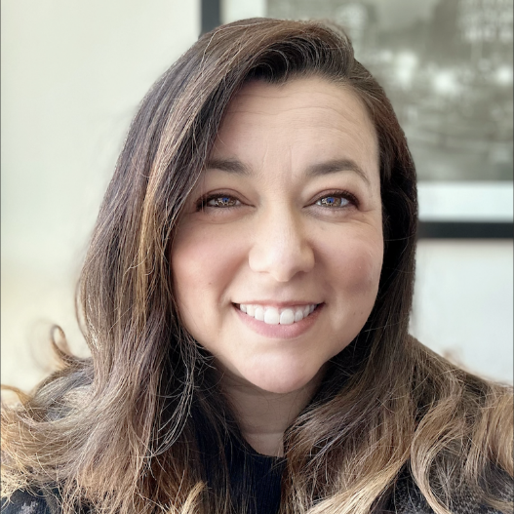
With over two decades of experience navigating the intersection of technology and collaboration, Sharon Gibbons is an expert in end-to-end privacy policy and deployment. As co-founder of Augusta Griffin, she creates novel solutions for sensitive data domains by uniting global providers and specialist teams. Her leadership experience includes a transformative five-year tenure at Meta, where she revolutionized academic partnerships and scaled research operations, and a decade at Technicolor leading marketing innovation strategy. Most recently, Sharon served as Director of Community Engagement for the OpenDP project, driving worldwide participation in open-source privacy tools.

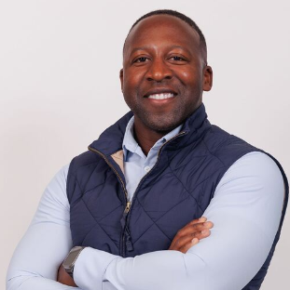
Yaw Etse is the Vice President of Data Engineering at Capital One, where he leads the Data Governance organization in Enterprise Data focusing on data anonymization, scalability, and operational efficiency. His role at Capital One involves driving innovative solutions and helping the company stay ahead in the competitive financial sector, especially through his involvement in projects on synthetic data and differential privacy. Yaw is actively collaborating with our Applied Researchers and academic engagement partners with Harvard on OpenDP and MIT on the Future of Data, to leverage research and advancements in secure data processing and privacy enhancing technologies here at Capital One.


Joseph Calandrino is an assistant professor at Carnegie Mellon University affiliated with the Department of Engineering and Public Policy, the School of Computer Science, and the CyLab Security and Privacy Institute. His research falls at the intersection of computer science with public policy. He previously served as acting chief science and technology advisor and acting chief AI officer at the U.S. Department of Justice and, for more than eight years, as research director in the Federal Trade Commission’s Bureau of Consumer Protection. He received his doctorate in Computer Science from Princeton University and a BS in Computer Science and Mathematics from the University of Virginia.

Naomi Lefkovitz
Bio coming soon.

Policy Panel Participants

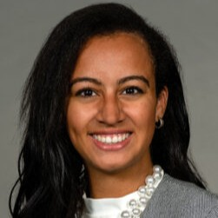
Tatiana Rice is the Senior Director of Legislation and Regulation at the Future of Privacy Forum. She helps lawmakers, industry leaders, and civil society navigate the evolving landscape of data privacy, AI, and emerging technology regulation and policy. She leads FPF’s strategic legislative and regulatory engagement at the state and federal levels, providing expert analysis, research, and guidance to support informed decision-making on AI policy and governance. Prior to joining FPF, Tatiana was at Shook, Hardy, & Bacon LLP, where she led biometric compliance efforts and supported industry clients in managing data privacy compliance, litigation, and investigations.

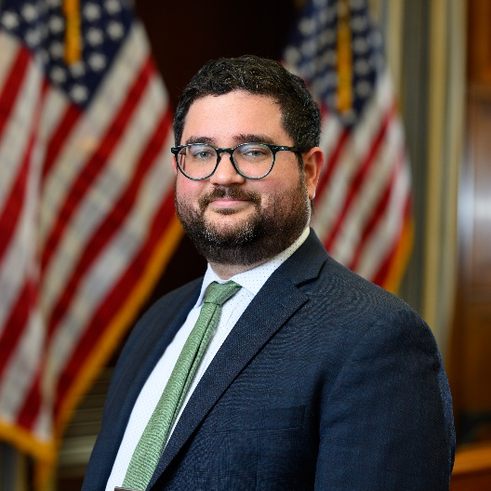
Alan McQuinn is a Professional Staff Member for the Research & Technology Subcommittee of the House Committee on Science, Space, and Technology. He advises Committee Members on a variety of issues related to information communications technology, such as cybersecurity, privacy, artificial intelligence, advanced manufacturing, and quantum information science. Alan McQuinn was previously a senior policy analyst at the Information Technology and Innovation Foundation. McQuinn has a Master’s in Public Policy from the McCourt School at Georgetown University and a B.S. from the University of Texas at Austin.

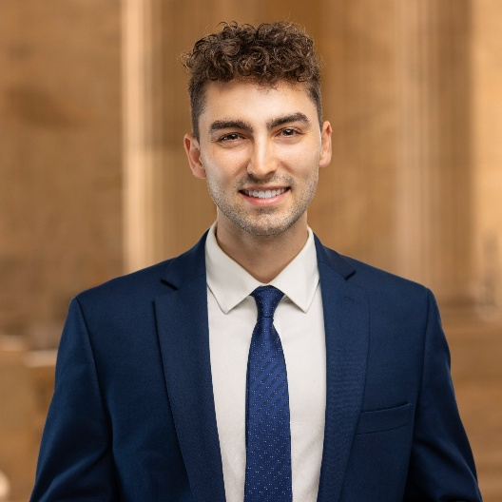
Dylan Irlbeck is a technologist focused on making government work better. Dylan currently serves as Legislative Assistant for Congresswoman Lori Trahan (MA-03), a senior Democrat on the House Energy & Commerce Committee, covering technology, consumer protection, and college sports issues. Dylan was previously a TechCongress fellow, serving with the Senate Finance and House Oversight Committees where he worked on policy related to government modernization, artificial intelligence, and antitrust. Earlier in his career, Dylan served as a Coding it Forward Fellow, developing public interest technology for the federal government.

Conference Sponsors

We are immensely grateful to the following sponsors for making it possible to have this conference and bring together researchers, data stewards, data practitioners, and public policymakers to discuss important issues around data privacy and public policy.






